Innovation Camp 2018
2nd -6th July at VIA University College, Herning
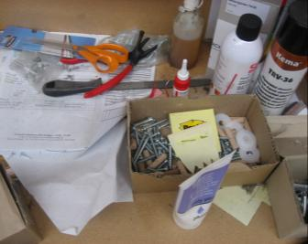
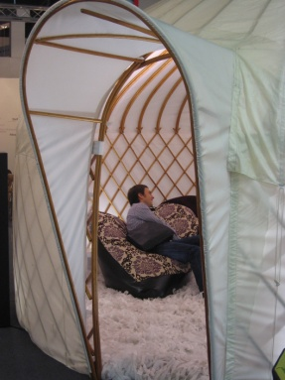
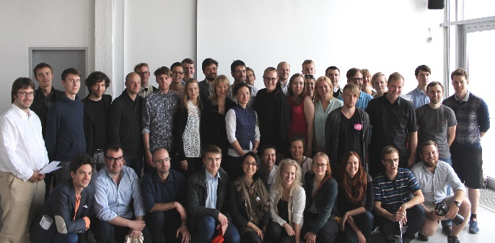

Do you want to be 1 of 3 design / engineering students, who get the opportunity to cooperate with other skilled students and companies from the whole Baltic Sea Region and ultimately have your ideas become real?

Interreg Baltic Sea Region project: BaltSe@nioR invites design students, who are, as a minimum in their second year (bachelor) to participate in Innovation Camp with participation from Sweden, Finland, Latvia, Lithuania, Poland, Estonia, Norway, Germany and Denmark.

During a 5-day camp the different cross- country and cross competence teams develop concepts and prototypes presenting innovative solutions for sustainable furniture and interior targeted the increasing population of people that are 65+ years. The whole process will be facilitated by skilled experts and you will learn different work methods, learn from your international team mates and work with furniture and interior companies from the Baltic Sea Region.

Participation is free – we pay your transport to and from camp + accommodation and food during camp.
You have to bring own computer and English language skills are mandatory.

If you want to participate, please apply by filling out the below profile and send it to joan@ldcluster.com at the latest 11th June12:00.
Selection of participants will be carried out immediately after and we will reply to everybody as soon as the 3 participants have been selected

Best regards Development Centre UMT
Secretariat for Lifestyle & Design Cluster
www.ldcluster.com

Students Profile

Participating students must be at least 2nd.year bachelor and speak and write English fluently. Students bring own computers and software to the camp.

Contact Data:
First Name: | Insert Photo
Family Name:
Home Address:
City:
Country:
Education ( Name of School):
Year: ( e.g. 3rd. year )
Email Address:
Mobile Number:

3D Scale Model Building/ prototypes:
 | Rookie | Skilled | Expert

Disciplins: | Pick your 3 strongest competences and rate them
 | Rookie/Light user | Skilled | Expert
Concept Design:
Product / Industrial Design:
Furniture/ Interior Design:
Interaction/Service Design:
Visual Communication:
Graphic Design:
3D Drawing / Rendering:
Ingeneering:
Materials:
Workshop skills:
Other – please specify:

Please list which 3D programs/ software you use ( for 3D printer set up)

For other comments

